SETI Systems Reflection Tool: A Guide for K–12 Educators Supporting Technology Integration
A guide for educators in using the Socio-Ecological Technology Integration (SETI) framework to assess what support and resources you need to successfully integrate technology.
Educator Level (Individual Beliefs and Practices)
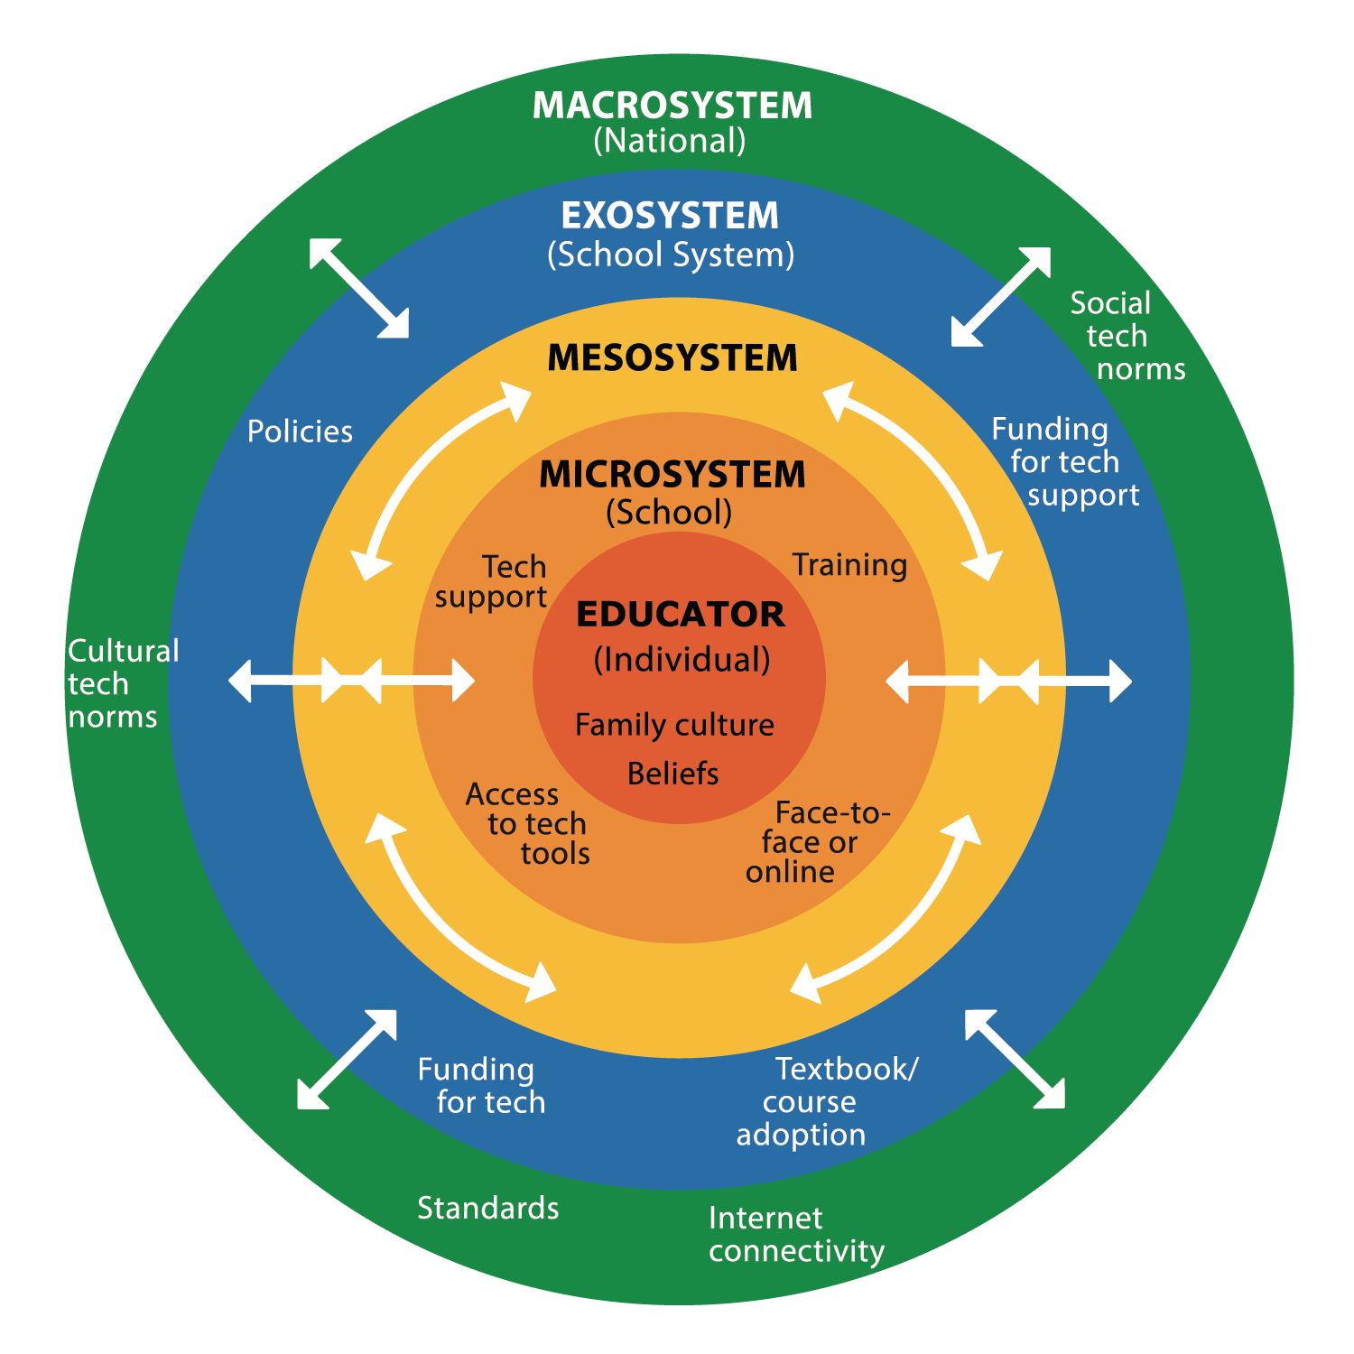
☐ Have you reflected on your personal beliefs about technology and how they influence your teaching?
☐ Are you aware of how family culture, traditions, and biases (your own and your students’) may shape perceptions of technology in education?
☐ Are you integrating technology in ways that align with effective pedagogical strategies and curriculum goals?

School Level (Microsystem)
☐ Does your school provide adequate access to technology (devices, software, and internet connectivity) for both educators and students?
☐ Are you actively participating in professional development opportunities related to technology integration?
☐ Is there technical support readily available to help you troubleshoot and resolve challenges?
☐ Are you working with colleagues and school leadership to build a culture of effective technology use?
☐ Are there clear school policies guiding safe, ethical, and effective technology use, and are you following them?

School District Level (Exosystem)
☐ Are you provided with district-wide policies and guidelines to support technology integration?
☐ Does your district allocate funding and resources to ensure technology access, support, and training?
☐ Are you advocating for needed improvements by sharing challenges and successes with district leaders?
☐ Do you engage in professional learning communities or district-led technology initiatives to stay informed?

National Level (Macrosystem)
☐ Are you aware of national policies, political priorities, and education standards, and do they support effective and equitable technology integration?
☐ Are you aware of how cultural, social, and political factors influence how technology is valued and adopted in education, and are you considering these influences in your practice?
☐ Is the government ensuring equitable access to technology, internet connectivity, and digital resources, and are you advocating for these needs in your school or district?
☐ Are you engaging in national conversations and professional networks to stay informed, share insights, and contribute to policy discussions on technology integration?

Cross-Cutting Elements (Mesosystem)
☐ Are policies and support structures aligned across school, district, and national levels to ensure consistency?
☐ Are all stakeholders, educators, administrators, and policymakers actively working together to create a well-supported, technology-integrated learning environment?

From: Crompton, H. (2025). A systems approach to technology integration: The SETI Framework. Revista Española de Pedagogía, 83(292), 511-531. https://doi.org/10.9781/rep.2025.412

