Socio-Ecological Technology Integration (SETI) Framework
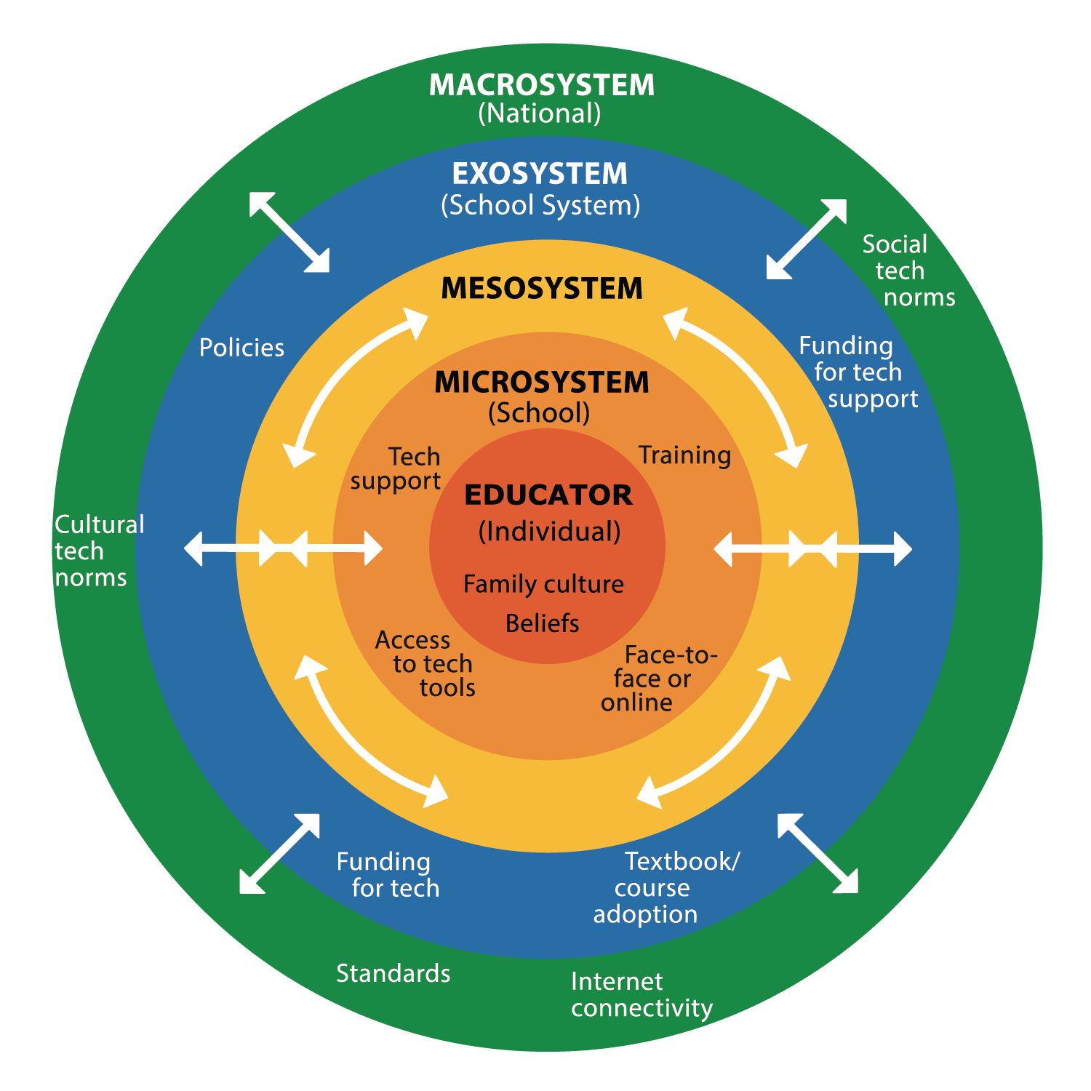
The SETI framework helps educators and leaders examine the broader ecosystem of policies, cultural values, resources, and support systems that shape how technology is integrated. By making these structures visible, SETI ensures integration strategies advance equity, protect cultural identities, and foster inclusive learning environments.
More information:
https://online.odu.edu/ridil/seti-framework
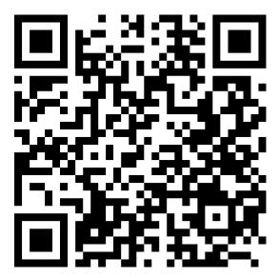

Citation:
Crompton, H., Burke, D., Nickel, C., & Chigona, A. (2024). The SETI framework and technology integration in the digital age. Asian Journal of Distance Education, 19(1).

