SETI Systems Reflection Tool: A Guide for Higher Education Faculty Advancing Digital Teaching
A guide for university faculty using the Socio-Ecological Technology Integration (SETI) framework to evaluate and strengthen support for effective technology integration in teaching and research.
Faculty Level (Individual Beliefs and Practices)
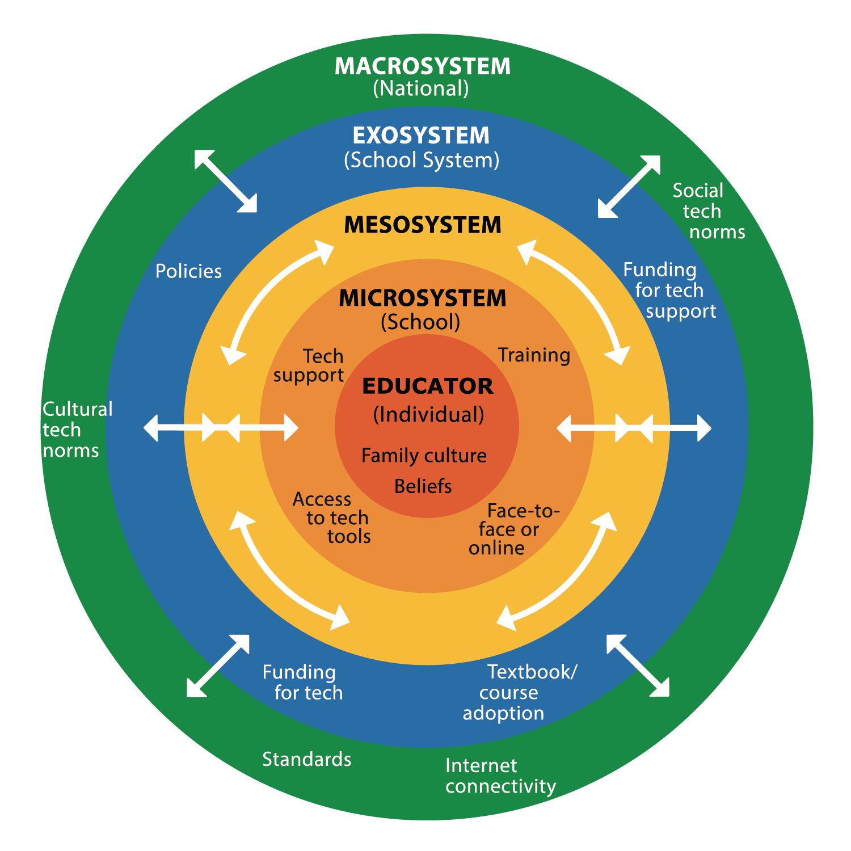
☐ Have you reflected on your personal beliefs about digital technology and its pedagogical value in higher education?
☐ Are you aware of how your cultural background, academic discipline, and student diversity influence your approach to technology integration?
☐ Are you aligning technology use with course learning outcomes, evidence-based pedagogical practices, and institutional teaching goals?

Institutional Level (Microsystem)
☐ Does your institution provide equitable access to necessary technology resources for faculty and students (e.g., hardware, software, bandwidth, digital library tools)?
☐ Are there professional development opportunities available to support pedagogical uses of technology in teaching and supervision?
☐ Is there dedicated technical and instructional design support for integrating technology into courses and research dissemination?
☐ Are academic departments and leadership fostering a culture that values and supports innovative and responsible technology use?
☐ Are institutional policies in place to ensure the ethical, accessible, and secure use of educational technologies?

University System and Regional Context (Exosystem)
☐ Are there coordinated efforts across faculties, campuses, or university systems to support scalable and consistent technology integration?
☐ Are you aware of system-wide investments in infrastructure and faculty development for digital teaching and learning?
☐ Are you contributing to or benefitting from faculty networks, cross-institutional initiatives, or regional consortia focused on educational technologies?
☐ Are you communicating needs or barriers to appropriate administrative leaders or committees to influence improvements?

National and Global Policy Context (Macrosystem)
☐ Are you familiar with national or international policies, funding streams, and quality frameworks that guide technology-enhanced higher education?
☐ Are you considering how national culture, higher education policy, and public attitudes influence institutional decision-making around technology?
☐ Are issues of digital equity and inclusion addressed in national initiatives, and are you advocating for these in your institution where needed?
☐ Are you participating in national or international communities of practice, policy consultations, or scholarly debates about the future of technology in higher education?

Cross-Cutting Considerations (Mesosystem)
☐ Are institutional strategies, policies, and supports aligned with system-wide and national policies to ensure coherent implementation?
☐ Are academic leaders, IT services, faculty governance bodies, and policy makers collaborating effectively to support meaningful and sustainable technology integration?

From:
Crompton, H. (2025). A systems approach to technology integration: The SETI Framework.
Revista Española de Pedagogía, 83(292), 511-531. https://doi.org/10.9781/rep.2025.412

