SETI Systems Reflection Tool:
For Higher Education Academic Leaders Building Institutional Support for Digital Learning
A guide for academic leaders (e.g., deans, provosts, vice chancellors) to evaluate and enhance the institutional systems and policies needed to support effective technology integration using the Socio-Ecological Technology Integration (SETI) framework.

Leadership in Supporting Faculty (Educator Level)
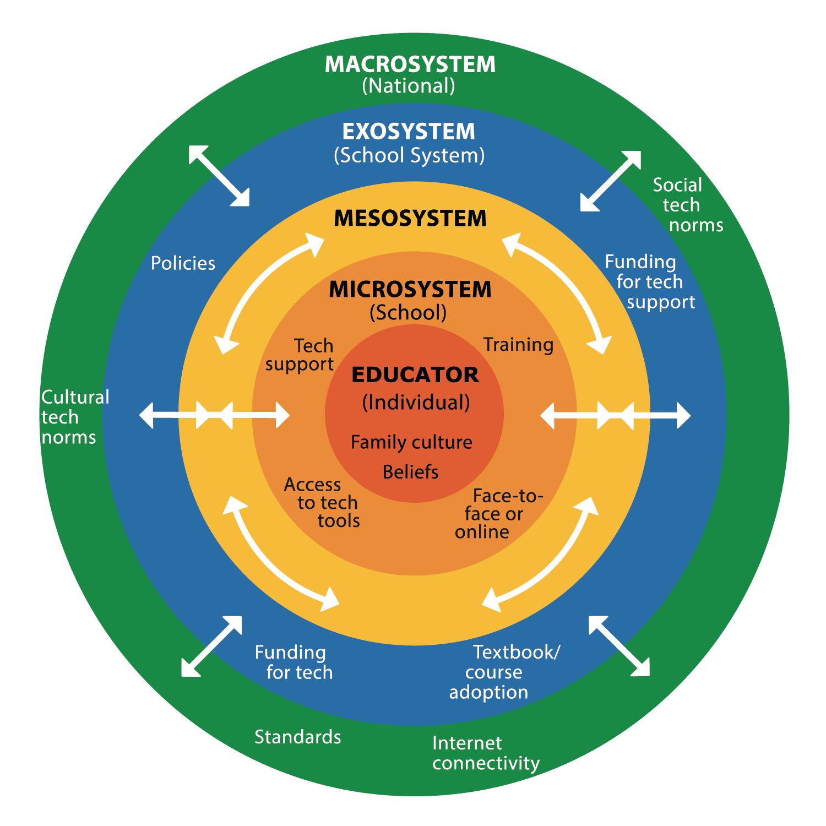
☐ Are you supporting faculty in reflecting on their educational beliefs and how these influence technology use?
☐ Are you providing mechanisms for inclusive decision-making that consider diverse faculty perspectives on technology integration?
☐ Are professional development programs available that align digital tools with pedagogical innovation and disciplinary expectations?

Leadership at the Institutional Level (Microsystem)
☐ Is your institution ensuring equitable access to robust technology infrastructure and digital learning environments for both faculty and students?
☐ Are institutional policies in place that address digital equity, accessibility, ethical use, and data security in educational technologies?
☐ Are units such as centers for teaching and learning, IT services, and digital pedagogy teams adequately resourced and aligned in their support of faculty?
☐ Are you fostering a culture of innovation and continuous improvement in technology-enhanced teaching, learning, and research?

Leadership Across University Systems and Partnerships (Exosystem)
☐ Are you engaged in cross-institutional or system-wide strategic initiatives for digital transformation in teaching and learning?
☐ Are you gathering and responding to data and feedback from faculty and students on technology integration challenges and opportunities?
☐ Are you investing in shared platforms, cloud services, or open educational resources that extend institutional capacity?
☐ Are you supporting collaborative research or community-engaged scholarship initiatives that integrate educational technologies?

Leadership in National and Global Contexts (Macrosystem)
☐ Are you staying informed about national digital education policies, international quality frameworks, and regulatory standards affecting technology use?
☐ Are you advocating for policy reform or funding that supports inclusive, innovative, and sustainable educational technology initiatives?
☐ Are you representing your institution in national or global digital education networks, alliances, or policy forums?
☐ Are cultural, social, and economic factors in your national and international context considered in strategic decisions about digital transformation?

Cross-Cutting Leadership Responsibilities (Mesosystem)
☐ Are institutional strategies aligned with broader system-level and national policies to ensure coherence in technology adoption?
☐ Are you facilitating cross-role collaboration (faculty, IT, instructional design, student services) to support an integrated digital learning ecosystem?
☐ Are monitoring and evaluation processes in place to assess the impact of technology integration on student success, equity, and teaching quality?

From:
Crompton, H. (2025). A systems approach to technology integration: The SETI Framework.
Revista Española de Pedagogía, 83(292), 511-531. https://doi.org/10.9781/rep.2025.412

