SETI Systems Reflection Tool: A Guide for K–12 Educators Supporting Technology Integration

A guide for educators in using the Socio-Ecological Technology Integration (SETI) framework to assess what support and resources you need to successfully integrate technology.

Educator Level (Individual Beliefs and Practices**)**

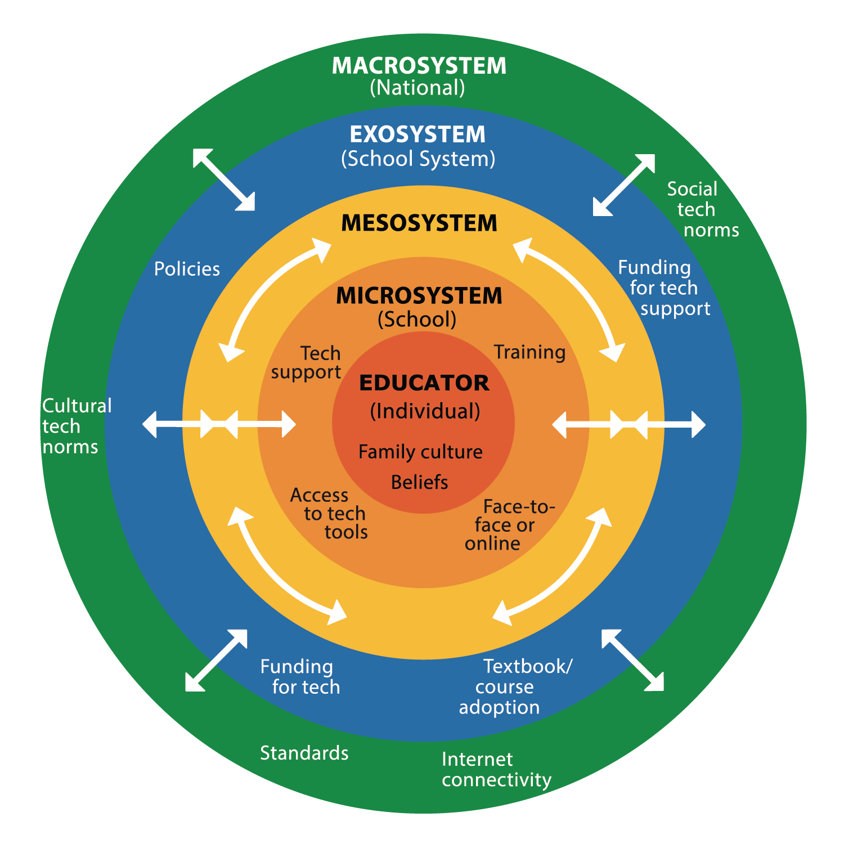

☐ Have you reflected on your personal beliefs about technology and how they influence your teaching?  
☐ Are you aware of how family culture, traditions, and biases (your own and your students’) may shape perceptions of technology in education?

☐ Are you integrating technology in ways that align with effective pedagogical strategies and curriculum goals?

# School Level (Microsystem)

☐ Does your school provide adequate access to technology (devices, software, and internet connectivity) for both educators and students?  
☐ Are you actively participating in professional development opportunities related to technology integration?  
☐ Is there technical support readily available to help you troubleshoot and resolve challenges?  
☐ Are you working with colleagues and school leadership to build a culture of effective technology use?  
☐ Are there clear school policies guiding safe, ethical, and effective technology use, and are you following them?

# School District Level (Exosystem)

☐ Are you provided with district-wide policies and guidelines to support technology integration?  
☐ Does your district allocate funding and resources to ensure technology access, support, and training?  
☐ Are you advocating for needed improvements by sharing challenges and successes with district leaders?  
☐ Do you engage in professional learning communities or district-led technology initiatives to stay informed?

# National Level (Macrosystem)

☐ Are you aware of national policies, political priorities, and education standards, and do they support effective and equitable technology integration?

☐ Are you aware of how cultural, social, and political factors influence how technology is valued and adopted in education, and are you considering these influences in your practice?

☐ Is the government ensuring equitable access to technology, internet connectivity, and digital resources, and are you advocating for these needs in your school or district?

☐ Are you engaging in national conversations and professional networks to stay informed, share insights, and contribute to policy discussions on technology integration?

# Cross-Cutting Elements (Mesosystem)

☐ Are policies and support structures aligned across school, district, and national levels to ensure consistency?  
☐ Are all stakeholders, educators, administrators, and policymakers actively working together to create a well-supported, technology-integrated learning environment?