SETI Systems Reflection Tool:  
For School and District Leaders Enabling Effective Technology Integration

A guide for educational leaders in using the Socio-Ecological Technology Integration (SETI) framework to assess whether the necessary policies, resources, and support structures are in place to facilitate effective technology integration.

# Leadership in Supporting Educators (Educator Level)

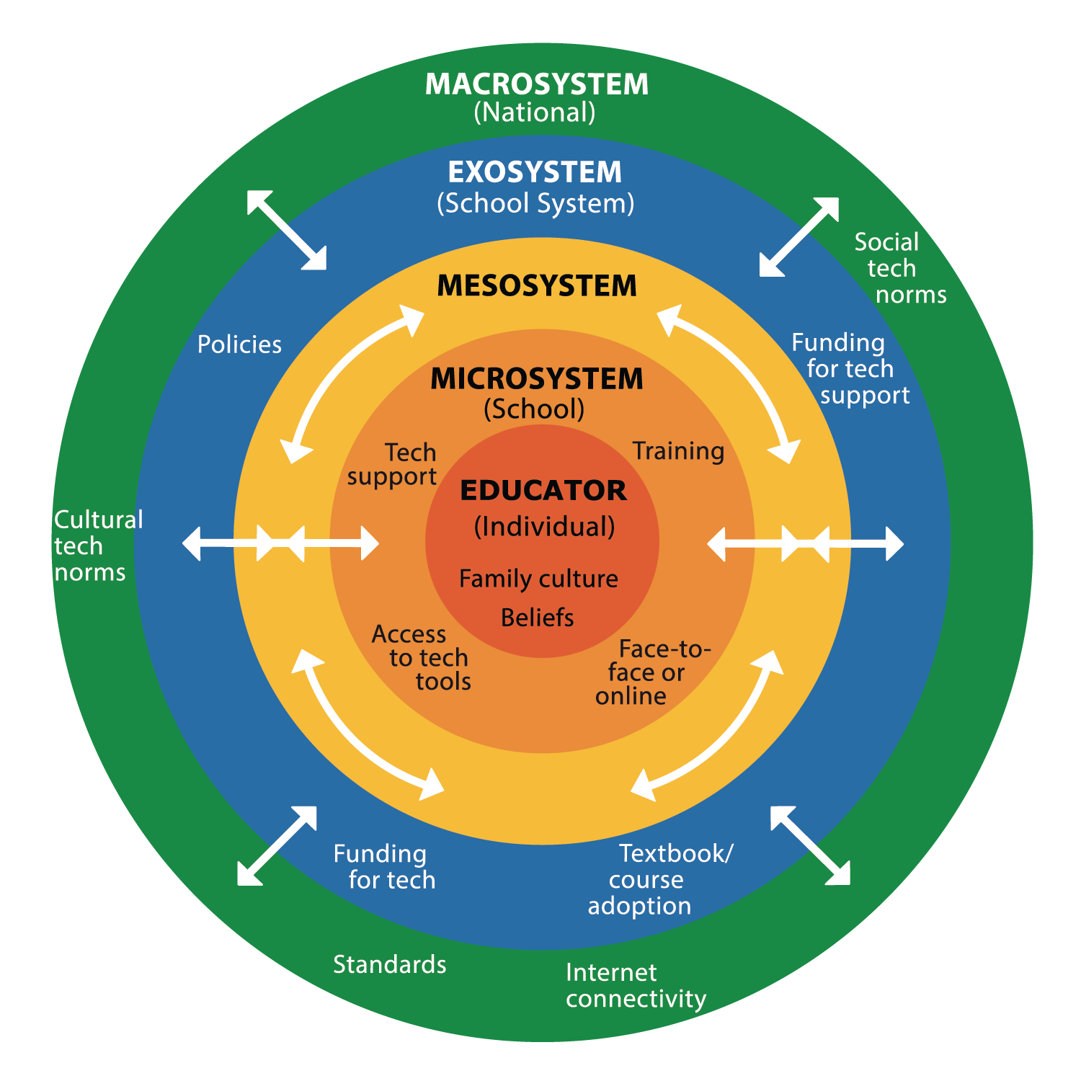

☐ Are you ensuring that educators have access to training and professional development to integrate technology effectively?  
☐ Are you fostering a culture where educators feel supported in exploring and reflecting on their beliefs about technology in learning?  
☐ Are you providing opportunities for educators to collaborate, share best practices, and learn from one another?

# Leadership at the School Level (Microsystem)

☐ Are you ensuring that educators and students have equitable access to technology, including devices, software, and reliable internet connectivity?  
☐ Are school policies in place to guide the safe, ethical, and effective use of technology in learning?  
☐ Is there a system for providing timely and effective technical support to educators and students?

# Leadership at the School District Level (Exosystem)

☐ Are district-wide policies and guidelines in place to support and standardize technology integration across schools?  
☐ Are there mechanisms for educators to provide feedback on technology-related challenges and successes?  
☐ Are you staying current and ensuring sufficient funding and resource allocation for technology access, training, and support?

# Leadership at the National Level (Macrosystem)

☐ Are you staying informed about national policies, political priorities, and education standards related to technology integration?  
☐ Are you advocating for government policies and funding that ensure equitable access to technology and digital learning resources?  
☐ Are you addressing how cultural, social, and political factors influence technology adoption and integration in education?

# Cross-Cutting Responsibilities (Mesosystem)

☐ Are you aligning policies and support structures across school, district, and national levels to create a consistent and effective technology integration strategy?  
☐ Are you facilitating collaboration among educators, administrators, and policymakers to build a well-supported technology ecosystem?