Research from the Office of RIDIL
Synthesizing Definitions of Digital Literacy for Web 3.0
This white paper provides a summary of the work from:
Greene, J. A., & Crompton, H. (2024). Synthesizing Definitions of Digital Literacy for the Web 3.0. TechTrends. https://doi.org/10.1007/s11528-024-01015-3
Research Author Bios:
Dr. Jeffrey Greene is the McMichael Distinguished Term Professor of Educational Psychology and Learning Sciences at the University of North Carolina at Chapel Hill's School of Education. Dr. Helen Crompton is a Professor of Instructional Technology in the Department of STEM and Professional Studies, and the Executive Director of the Research Institute for Digital Innovation in Learning at ODUGlobal at ODU.
Overview
In recent years, the term "digital literacy" has taken on significant importance in educational discourse as society increasingly integrates digital technologies into everyday life. The increasing prevalence and complexity of digital technologies highlights the pressing need for educators and policymakers to adopt a broader understanding of digital literacy. Initially rooted in media and new literacies scholarship, digital literacy has expanded to encompass technical, cognitive, cultural, and ethical dimensions. This study synthesizes definitions of digital literacy in the context of modern technologies like social media, offering insights for educational policy, instructional design, and learner development.
Purpose of Research
The research examined and synthesized existing definitions of digital literacy to create an encompassing definition relevant to the evolving presence of digital technology in multiple aspects of everyday life. By doing so, the study answered the following research questions:
- How have scholars defined “digital literacy”?
- What are the various facets of scholars’ definitions of “digital literacy”?
- What could a synthesized definition of “digital literacy” include?
Method
The study employed a systematic review methodology to analyze how digital literacy has been conceptualized and applied in academic research from 2018 to 2023. Analysis of the research involved cataloging definitions of digital literacy across disciplines and coding these definitions based on recurring themes. Additionally, the authors examined how digital literacy frameworks address emerging trends including artificial intelligence, decentralized systems, and the semantic web.
Findings and Discussion
From the research, a broad understanding of digital literacy is provided by answering the following three questions.
How have scholars defined “digital literacy”?
The research revealed that definitions of digital literacy differed in the skills mentioned, their focus on acquiring information versus generating knowledge, and their emphasis on sociocultural or other socioemotional factors. The authors caution that this variability in definitions could lead to fallacies in operationalization and measurement and a proliferation of digital literacy theories. Synthesis of these definitions is needed.
What are the various facets of scholars’ definitions of “digital literacy”?
Coding of the data resulted in sixteen unique facets in scholars’ definitions of digital literacy. These facets are listed in table 1 below in order of frequency coded.
Table 1 Unique facets of definitions of digital literacy
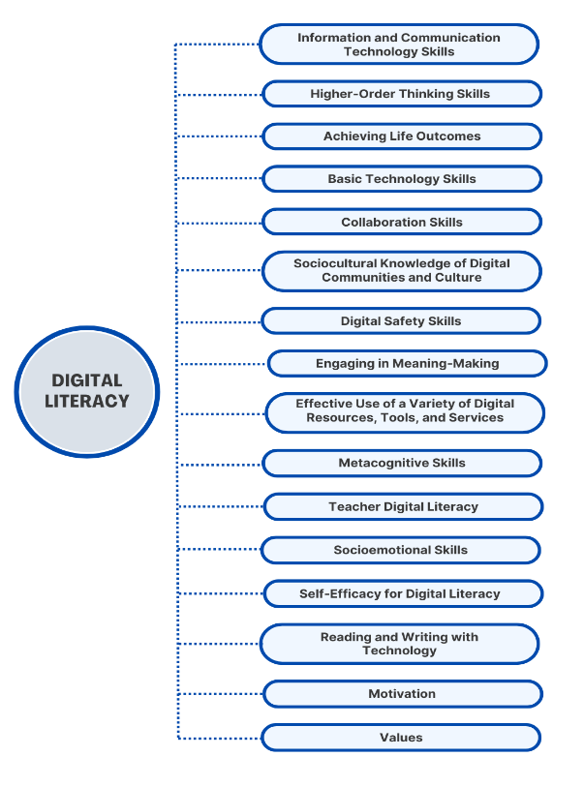

As digital literacy’s roots are grounded in scholarship on Information and Communication Technology (ICT) skills, it is not surprising that ICT skills were the most coded category. The second most frequently coded category was Higher-Order Thinking Skills, which included a variety of skills associated with knowledge generation. Twenty-nine percent of definitions characterized digital literacy in terms of its purpose, referring to a variety of life outcomes for which digital literacy was presumed to be needed. Collaboration skills and sociocultural knowledge of digital communities and culture were found in fifteen percent or fewer of the articles. Digital safety skills were coded in only 12 percent of articles. Socioemotional skills were mentioned with a focus on the skills needed to engage effectively in one-on-one interactions. Finally, teacher digital literacy emerged as a unique category given certain definitions’ focus on teachers possessing both digital literacy skills as well as the pedagogical content knowledge.
What could a synthesized definition of “digital literacy” include?
After coding and integrating the facets of definitions and digital literacy, the authors created a synthesized definition of digital literacy:
Digital literacy is guided by the affordances and constraints of context as well as the developmental capacity of the individual, and involves the skills needed to find, access, manage, critique, and integrate information in technology contexts, as well as the ability to build knowledge from that information via metacognition, critical thinking, problem solving, and creativity, all in the service of achieving a variety of desirable life outcomes spanning work, leisure, and civic engagement (Greene & Crompton, 2024).
The researchers caution that there are important nuances to this single definition of digital literacy. First, the sociocultural aspect of digital literacy requires that any definition be flexible enough to be contextualized to specific groups or contexts. Second, definitions should be adapted, depending upon the targeted population and the communities and systems people typically encounter at different life stages. Finally, as society evolves and what is novel becomes common and understood, it may be productive to refine definitions of digital literacy.
Conclusion
The study underscores the need for a redefined and comprehensive understanding of digital literacy in the modern world. By synthesizing contemporary definitions, the research highlights the importance of integrating technical, cognitive, ethical, cultural, and collaborative dimensions into digital literacy frameworks. These insights are critical for educators, policymakers, and institutions seeking to prepare learners for the complexities of the modern digital age.
References
Greene, J. A., & Crompton, H. (2024). Synthesizing Definitions of Digital Literacy for the Web 3.0. TechTrends. https://doi.org/10.1007/s11528-024-01015-3

